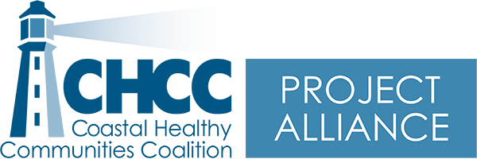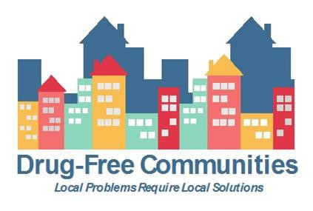

Minutes – Project Alliance Coalition Meeting www.chccme.org

Wednesday, February 16, 2022, 9:00-11:00 am Virtual Meeting
Present: Morgan Bates, Cheri Sullivan, Tricia Cote, Robert MacKenzie, Christina Schechtman, Maxine Darling, Maegan Lambert-Irish, Alissa Wigglesworth, Victoria Frankl, Kayla Beaulieu, Jack Clements, Erica Gates, Alexa Christie, Edward Kato, Eriko Farnsworth

 | Item | Details | Next Steps
1 | Welcome and introductions | - Erica Gates joined us for the first time today. Erica works at the Wayfinder School which grew to form Passages for teens who were pregnant or parenting, and then expanded statewide to provide home-based education to help teens struggling in school settings. https://www.wayfinderschools.org/ | Contact Information:  ericag@wayfinderschools.org
2 | Alissa Wigglesworth, Tobacco Prevention Coordinator, Partners for Healthier Communities | - Vaping and E-Cigarettes  - Please see attached for her presentation*Please reach out to Alissa if you want to share this information with anyone. | Contact Information:  awiggleswo@smhc.org
3 | Victoria Frankl,  Maine Education Coordinator, Northern New England Poison Center | - Marijuana Education  - Please see attached for her presentation | Contact Information:  Victoria.Frankl@mainehealth.org
For those who cannot attend Wednesday meetings, we are offering a once-a-month meeting every 4th Friday from 12:00-1:00 pm to share updates and connect. We hope that day works for some! Our first one will be on February 25, 2022. (Meeting ID: 939 1226 3882)
Next Meeting: March 16, 2022, 9:00-11:00 am
Topic: Coalition Overview and Member Updates Location: Zoom https://une.zoom.us/j/95498450554

