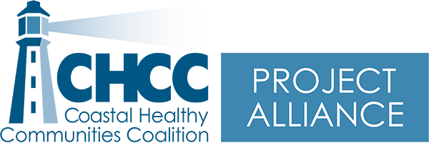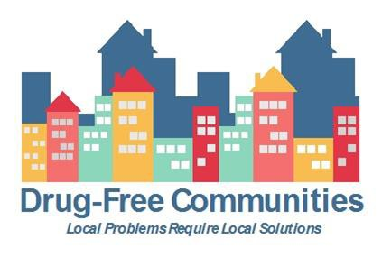

Minutes – Project Alliance Coalition Meeting www.chccme.org
Wednesday, January 19, 2022, 9-11:00 am, Virtual Meeting
Present: Morgan Bates, Cheri Sullivan, Tricia Cote, Robert MacKenzie, Ashley Duffee, Christina Schechtman, Maxine Darling, Maegan Lambert-Irish, Jack Clements, Abigail Smallwood, Jordan Thompson, Alyssa Pelchat, Brook Bowley, Eriko Farnsworth

Purpose: Monthly Coalition Meeting

 | Item | Details | Next Steps
1 | Welcome and Introductions |  | - N/A
2 | Psychological First Aid and Mental Health First Aid | Margaret Norbert MSW, LCSW, LICSW, spoke about ConnectME to Better Mental Health. This a program through Sweetser and is funded through SAMSHA to provides Mental Health First Aid (MHFA) and Psychological First Aid (PFA) training to individuals who are in roles that respond to and manage traumatic events, including first responders and teachers. | For more information please contact Maggie  Margaret.norbert@yu.edu  Phone: 207 808-0398
3 | Coalition Updates | - April 30^{th,} 2022, is Drug Take-Back Day.  - Saco PD has partnered with Spurwink to bring a community liaison role to support mental health.  - Eriko, with the DEA360, is working to get vaping drop boxes in schools and wants to partner with the PDs to transport materials for Drug Take-Back Day, so it can be included in the count. Eriko is also looking for help partnering with Youthful Maine to offer Drug Take-Back while people are accessing the food distribution.  - Eriko shared their success collaborating with UNE/Pharmacy students to do harm reduction events in Portland.  - Alyssa, with Options, is working to get naloxone into her area schools. This is an effort she is doing outside of her work for Options. New legislation was passed October 2021 which established guidelines for the administration of naloxone in Maine’s public and private schools.  - A bill to strengthen Maine’s Good Samaritan laws is being reviewed by the legislature. LD 1862, aims to strengthen Maine’s Good Samaritan Law by closing some loopholes to protect anyone at the premises of an overdose.

Next Meeting: February 16, 2022, 9-11:00 am on ZOOM, Meeting ID: 963 5802 5214
Topics: Marijuana and Tobacco Tends in Youth
Guest speakers: Alissa Wigglesworth, York County Tobacco Prevention Coordinator with Partners for Healthier Communities,
Victoria Frankl, Maine Education Coordinator with Northern New England Poison Center

